16/09/26 | Children & Young People Mental Health Service  Haringey MHST GEMHS  Oak Building  St. Ann’s Hospital  St. Ann’s Road  Tottenham  London N15 3TH  Telephone:  020 8702 3400  Email: nlft.haringeycamhsgemhsinbox@nhs.net  Website: Our Services Page | North London NHS Foundation Trust
Dear Parent/carer,

Introducing: The GEMHS Team
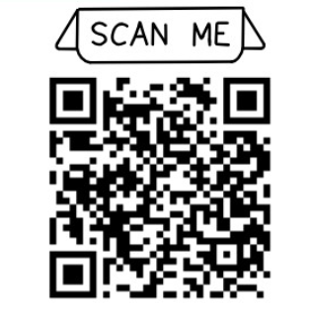

Find out more about us by visiting: www.londonwaitingroom.nhs.uk/haringey-gemhs
or by scanning the QR code:

GEMHS are a Mental Health Support Team (MHST) based in educational settings across Haringey. We aim to help all children and young people to succeed and achieve their full potential by working with school to provide a range of evidence-based emotional wellbeing support throughout the school year, including:

- Group work
- Whole class work and assemblies
- Psychoeducation workshops for young people, parents and carers
- Drop-in sessions, training and consultation for school staff
- Supporting ‘peer mentoring’ programmes
- Signposting to help children and young people access the right support
- Building on schools’ current wellbeing provision

Please follow this link – https://www.northlondonmentalhealth.nhs.uk/data-protection – to find out how we handle personal data and information.

If you do not wish for your child to be involved in any support we are offering this year, please inform your educational setting by 22nd September 2026.

We also offer one-to-one guided self-help interventions based on Cognitive Behavioural Therapy, with young people in secondary schools and through parents/carers in primary schools. Referrals for this part of our offer are made to GEMHS by educational settings. Please speak to your educational setting if you/your child would like to access this support.

You can find out more about our team on www.londonwaitingroom.nhs.uk/Haringey-gemhs or by emailing us at nlft.haringeycamhsgemhsinbox@nhs.net

Yours faithfully,

Georgia Fletcher
Educational Mental Health Practitioner
Haringey GEMHS
Haringey Mental Health Support Team

